28th July 2015

**YOKOHAMA to Exhibit at Indonesia Auto Show**

Tokyo ‒ The Yokohama Rubber Co., Ltd., announced today that it will participate in the GAIKINDO Indonesia International Auto Show 2015 to be held from 20th to 30th August (press day on 20th August 2015) in South Tangerang’s BSD City. YOKOHAMA will be represented at the show by its Indonesian sales agent, PT YHI INDONESIA.

*\*GAIKINDO : The Association of Indonesia Automotive Industries*

In keeping with the theme of “Delivering the Future”, the YOKOHAMA booth will feature displays that appeal to the high performance driving and environmental commitment provided by YOKOHAMA tyres incorporating the latest technology. Considering the huge demand for eco cars and SUVs in Indonesia, the main products to be displayed, will be the fuel-efficient “BluEarth” brand suitable for eco cars and the “GEOLANDAR” range of SUV tyres. The booth will also display YOKOHAMA’s “ADVAN” global flagship tyre, which symbolises the high-performance delivered by all YOKOHAMA products. In addition, a section of the booth will include a special infographic display of Chelsea FC promoting the partnership between England’s Premier League football club and YOKOHAMA as Chelsea´s shirt sponsor from this month.

The “GAIKINDO Indonesia International Auto Show” is a new show, being held for the first time in 2015. PT YHI INDONESIA has already represented YOKOHAMA previously at Indonesia´s other Motor Show IIMS (Indonesia International Motor Show).

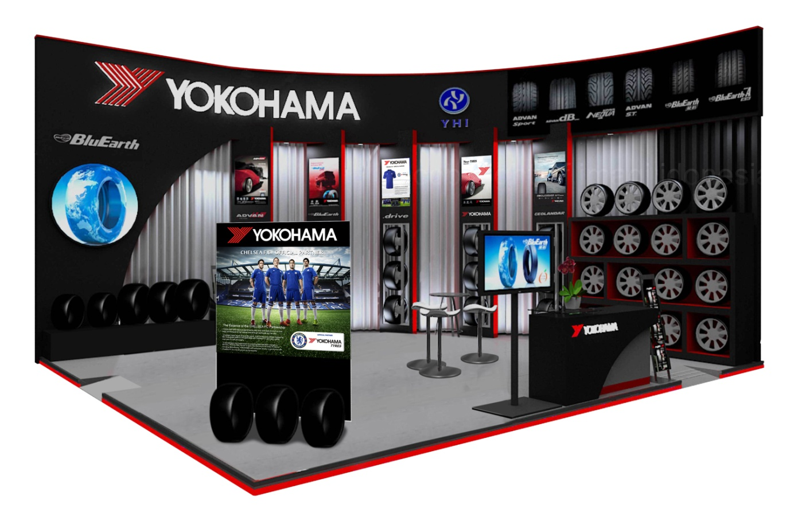***Image of Yokohama booth***